Visual Arts Cheshire (VAC) - Artist Agreement

Surname: First Name:

Contract Start: Contract End: 22/02/2025

I, the above, agree to leave work (as detailed on a separate delivery sheet) with VAC Gallery, Baron’s Quay, Northwich, on the following terms:

- The work will be left with VAC for a period of one month for the purposes of sale and unsold work must be collected after the contract ends.

- ANY WORK LEFT 30 DAYS AFTER THE EXPIRATION OF THE CONTRACT WILL BE DISPOSED OF, unless an extension has been
Agreed with VAC

- During the period of this agreement, VAC will be the sole selling agent of the work on consignment. VAC will take a commission of 20% of the sale price. Work should therefore be priced accordingly.

- The title to the work remains with the artist until all monies owing under the agreement have been received at which time the ownership will pass to the purchaser.

- 20% commission will be deducted from the retail price and the remaining balance will be forwarded to the artist.

- At the termination of this agreement, all unsold work must be collected by the artist. If any work remains uncollected 30 days after the end of this contract, VAC will have the right of ownership of the work.

- Work will immediately be placed out for sale. VAC will not accept responsibility for misspelling items that are incorrectly labelled or priced.

- VAC does not accept liability for damage, loss, or theft of work whilst it is in the care of the gallery. We would therefore encourage you to insure your own goods whilst on exhibition. VAC shall inform the artist immediately should any loss or damage occur and agrees not to make any repairs without the consent of the artist.

- VAC acknowledges the artist’s right to be identified as the author of the work.

- VAC is aware of Copyright Law and agrees not to allow any work to be used (e.g. for publicity purposes) without the artist’s permission.

- VAC agrees to release the work to the artist on request (at any time when the gallery is open), during the term of this agreement.

- It is mutually agreed that should either party change address they will inform the other.

- VAC has the sole right to decide whether to accept and exhibit work.

VAC representative signature | 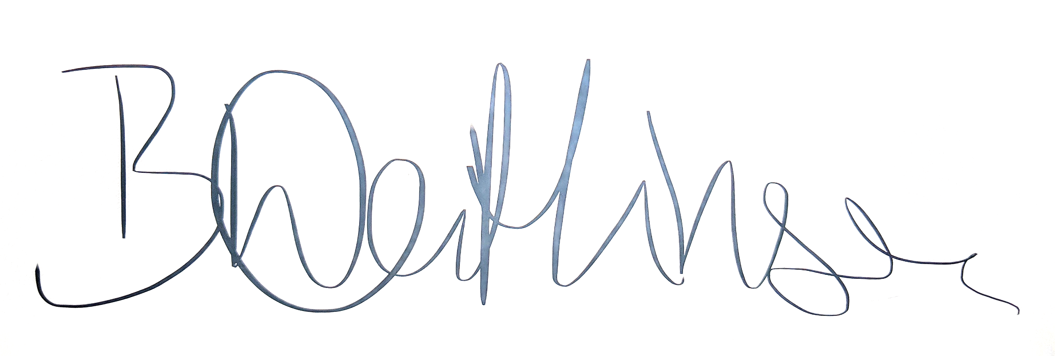
VAC representative name (block capitals) | Brigitte Watkinson
Artist signature
Artist name (block capitals)
Date

